Installing Docker on Windows Server
- Let’s create a Windows Server 2016 instance in any cloud
- Docs from Microsoft(https://docs.microsoft.com/en-us/virtualization/windowscontainers/deploy-containers/deploy-containers-on-server)
- Launch PowerShell as admin and execute the following commands
Set-ExecutionPolicy unrestricted
[Net.ServicePointManager]::SecurityProtocol = [Net.SecurityProtocolType]::Tls12
Install-Module -Name DockerMsftProvider -Repository PSGallery -Force
Install-Package -Name docker -ProviderName DockerMsftProvider
Restart-Computer -Force
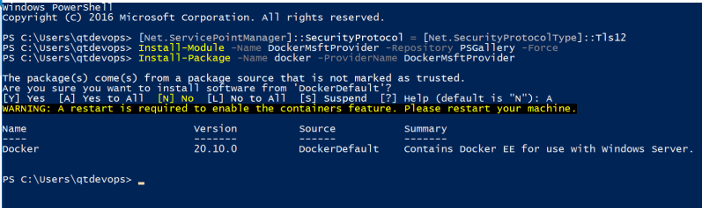
- Post machine restart, Launch PowerShell as admin
docker info
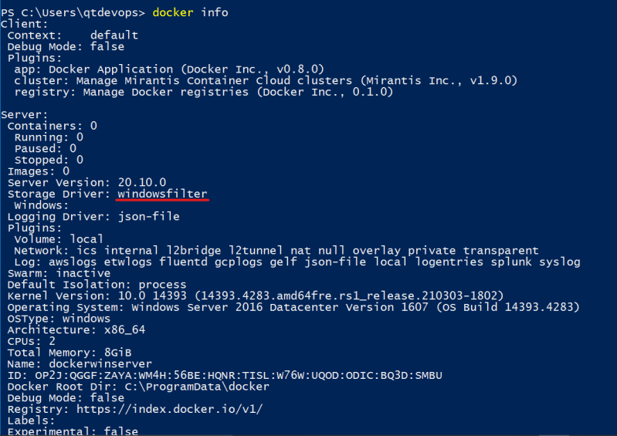
- Now lets try to pull iis server image 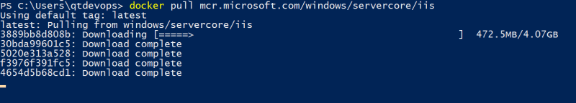
- Now lets run the container 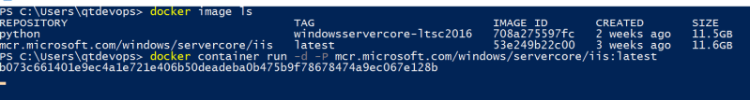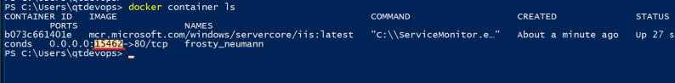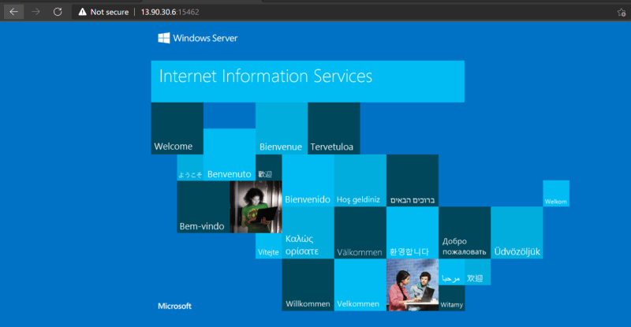
- Run the following command
docker container exec -it <container id/name> powershell
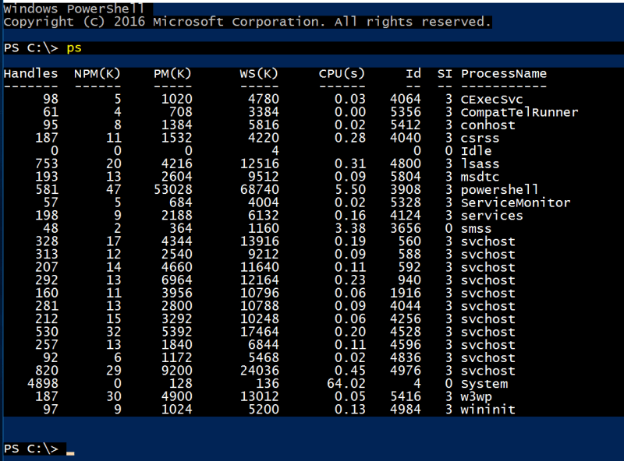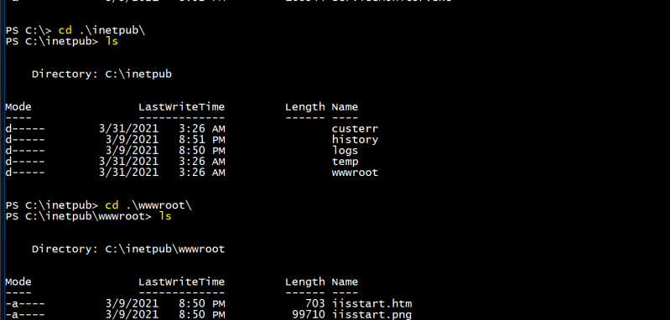
- Launch powershell as admin & then execute docker info

